Effort Estimation
Effort estimation is the process of predicting the amount of work (normally expressed in person-months), the cost, and the duration required to develop a software product. It is performed when information is incomplete and is refined iteratively as the project progresses.
Why it is difficult
- Requirements are often incomplete, ambiguous, or unstable.
- Software is intangible, productivity varies widely with people, technology, and domain.
- Historical data from previous projects may not match the new project.
- Human factors (skill, motivation, communication overhead) introduce high uncertainty.

Project Planning Framework
Before detailed estimation begins, the following steps are performed:
- Establish the project scope (what is in and what is out).
- Determine technical and business feasibility.
- Perform initial risk analysis.
- Identify the resources required (people, hardware, software, tools).
- Estimate effort and cost.
- Develop the project schedule.
Structure
Software Project Estimation
├── Decomposition Techniques
│ ├── Problem-based (LOC / FP)
│ ├── Process-based
│ └── Use-case based
└── Empirical Estimation Models
├── COCOMO / COCOMO II
├── Software Equation (Putnam)
└── Other regression-based models

Major Estimation Techniques
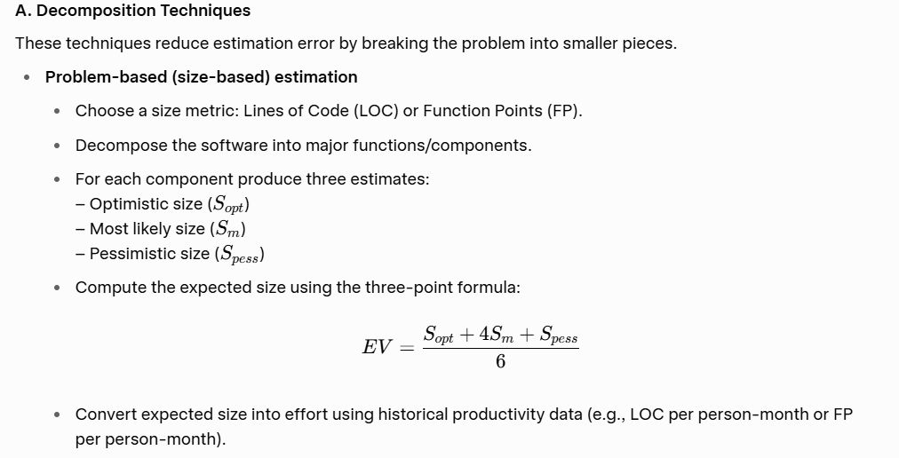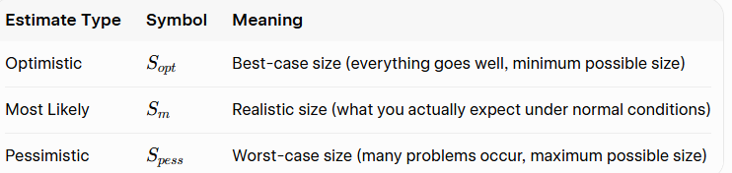

Compute the Expected Size (EV) using the Three-Point Formula

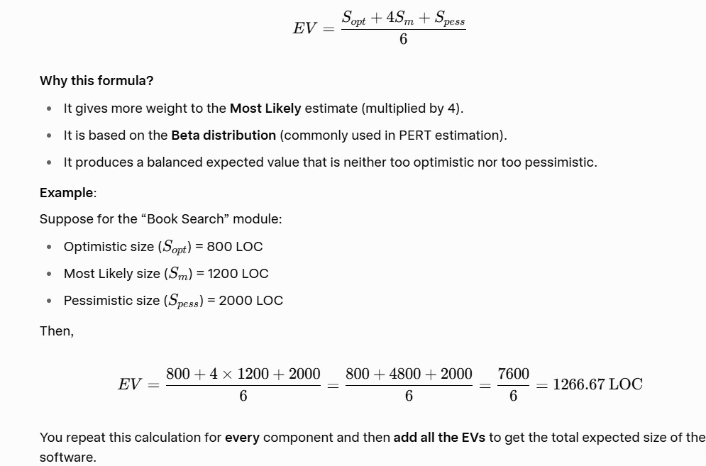

Convert Expected Size into Effort
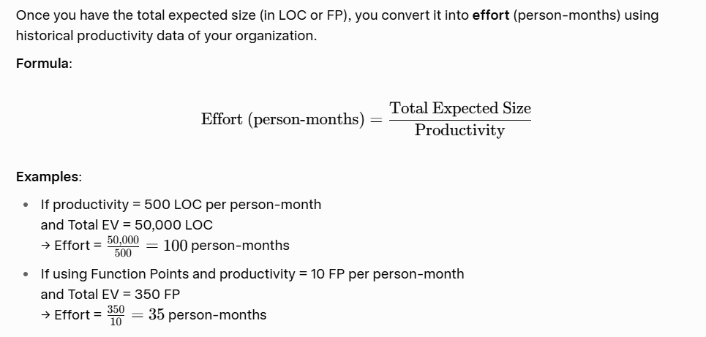

- Process-based estimation Allocate percentages of the total effort to the major process activities (customer communication, planning, risk analysis, engineering, construction, deployment, etc.). The percentages are adjusted according to project type, size, and complexity.

Use-Case Based Estimation (later editions)
Estimate based on the number and complexity of use cases.
Convert use cases into effort using historical productivity data.

B. Empirical / Parametric Models
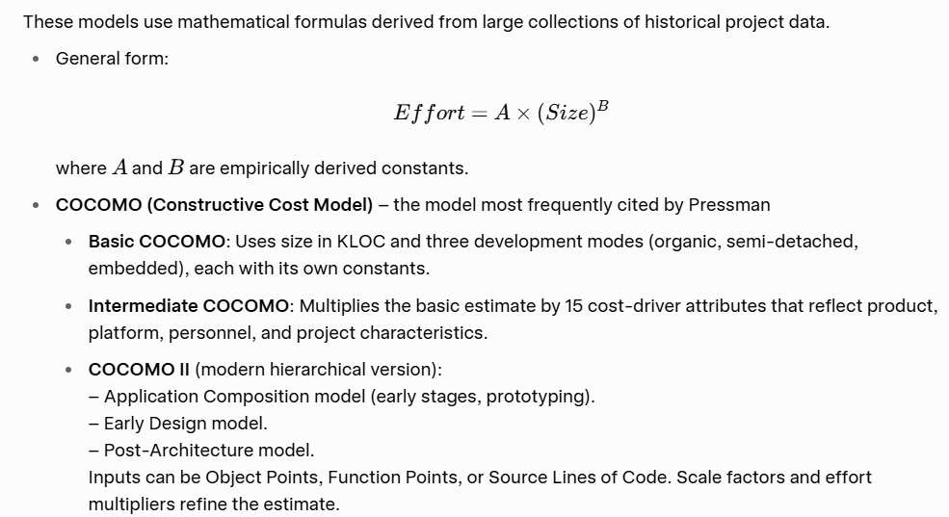
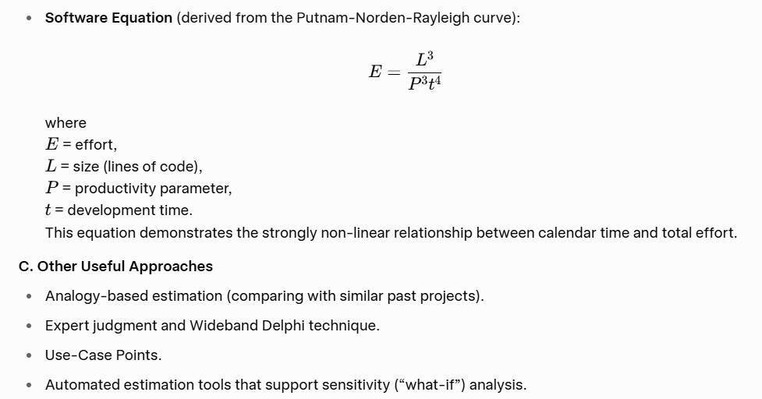
Empirical Models
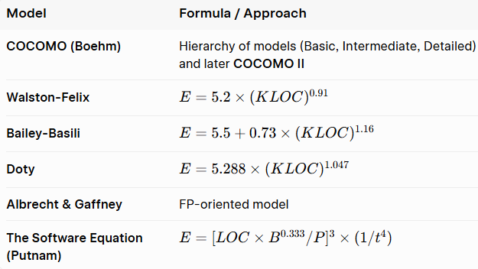

Introduction to COCOMO Model
COCOMO stands for Constructive Cost Model.
It is one of the most popular and widely used software cost estimation models in software engineering.
COCOMO was developed by Dr. Barry W. Boehm in 1981. It helps project managers estimate the effort (in person-months), time (in months), and cost required to develop a software project.

Why is COCOMO Important?
- It provides a systematic and scientific way to estimate software development effort.
- It is based on historical data from real software projects.
- It helps in better project planning, budgeting, and scheduling.

Basic Idea of COCOMO
COCOMO estimates the effort required based mainly on the size of the software.
The size is usually measured in KLOC (Kilo Lines of Code), i.e., thousands of lines of source code.
The basic relationship is:
Effort increases as the size of the software increases.

Three Types of Projects in COCOMO
COCOMO classifies software projects into three categories (modes):
- Organic Mode
  - Small and simple projects
  - Small team with good experience
  - Example: Simple business applications, payroll systems
- Semi-Detached Mode
  - Medium-sized projects
  - Team has mixed experience
  - Example: Database systems, utility software
- Embedded Mode
  - Complex and large projects
  - Strict constraints (real-time, hardware, safety)
  - Example: Air traffic control systems, military software

Levels of COCOMO
COCOMO has three levels of detail:
- Basic COCOMO → Rough estimate using only size
- Intermediate COCOMO → More accurate (uses size + 15 cost drivers)
- Detailed COCOMO → Most accurate (considers different phases of the project)

- COCOMO / COCOMO II (Barry Boehm)

Original COCOMO (COCOMO 81)
It is a hierarchy of three models:
- Basic COCOMO: Uses only size (KLOC) and project mode.
- Intermediate COCOMO: Adds 15 cost drivers (Effort Adjustment Factor – EAF).
- Detailed COCOMO: Applies cost drivers phase-wise.
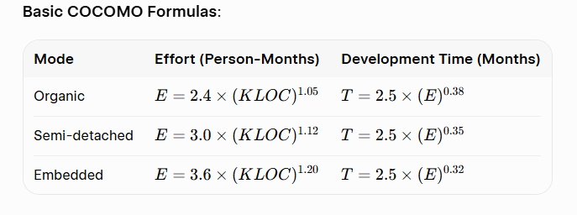
COCOMO II (Modern version)
Highlights COCOMO II as an improvement that supports modern development practices. It has three sub-models:
- Application Composition Model – Early stage, uses Object Points.
- Early Design Model – Uses Function Points or KSLOC + limited cost drivers.
- Post-Architecture Model – Most detailed, uses 17 cost drivers + 5 scale factors.
General form of COCOMO II:
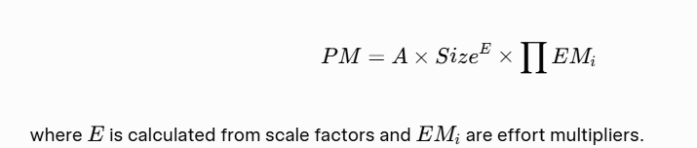
The Software Equation (Putnam Model / SLIM)
Developed by Lawrence H. Putnam. It is a dynamic multivariable model based on the Norden-Rayleigh curve (staffing profile follows a Rayleigh distribution).
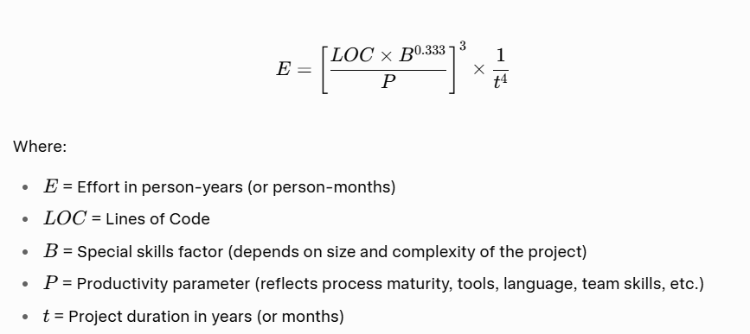

Key Characteristics:
- Highly non-linear relationship between effort and time.
- Extending the schedule can significantly reduce total effort (and vice versa).
- Productivity parameter P is calibrated from historical data of the organization.
- Typical values of P:
  - Real-time embedded → ~2000
  - Systems/telecom → ~10,000
  - Business applications → ~28,000
Simplified forms sometimes used:
- Minimum development time
- Effort in terms of time
This model is the foundation of the commercial SLIM (Software Lifecycle Management) tool.
- Other Regression-Based Models
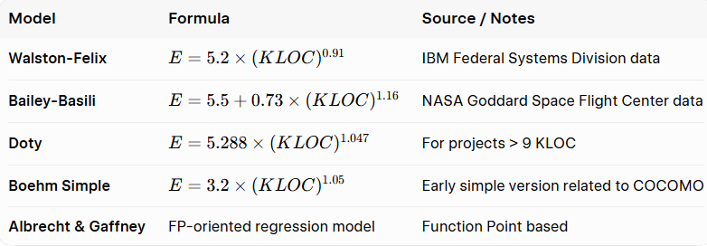

Example 1: Organic Mode
Problem:
A simple business application is estimated to be 40 KLOC.
It is an Organic type project.
Calculate:
- Effort (Person-Months)
- Development Time (Months)
- Average Staff required
Solution:
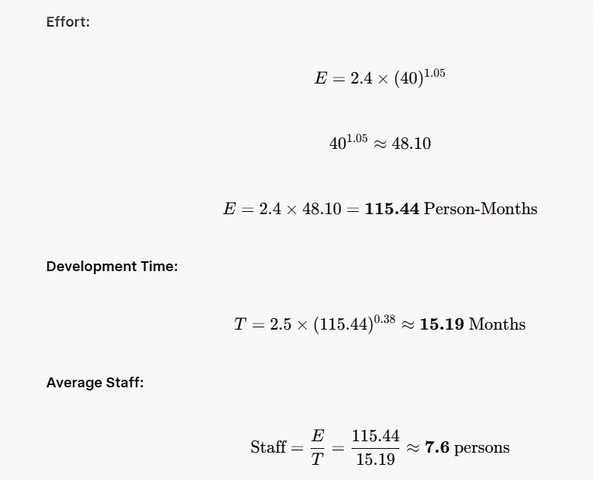

Example 2: Semi-detached Mode
Problem:
A utility software project is estimated at 100 KLOC.
It is a Semi-detached type project.
Calculate Effort, Time and Staff.
Solution:
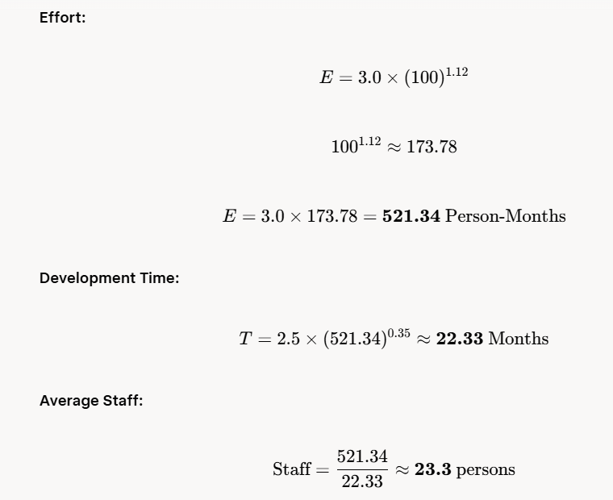

Example 3: Embedded Mode
Problem:
A real-time control system is estimated at 150 KLOC.
It is an Embedded type project.
Calculate Effort, Time and Staff.
Solution:
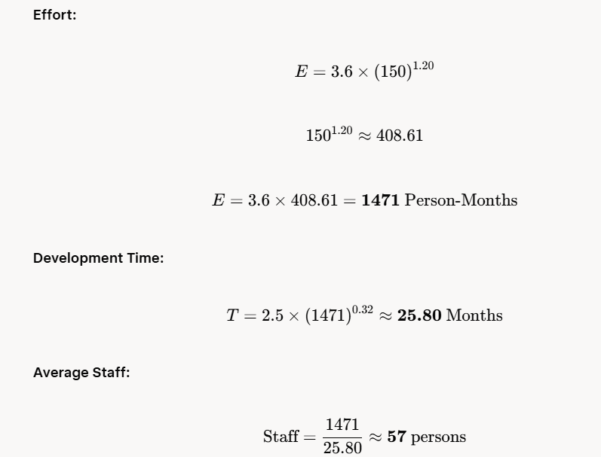
4.
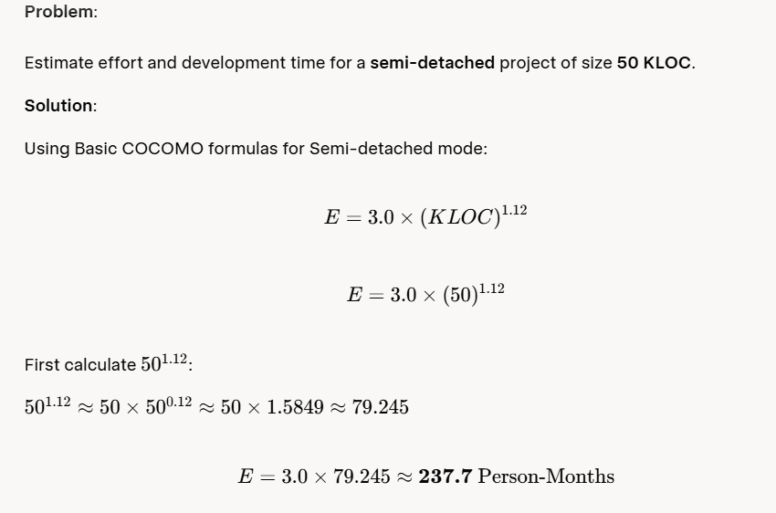

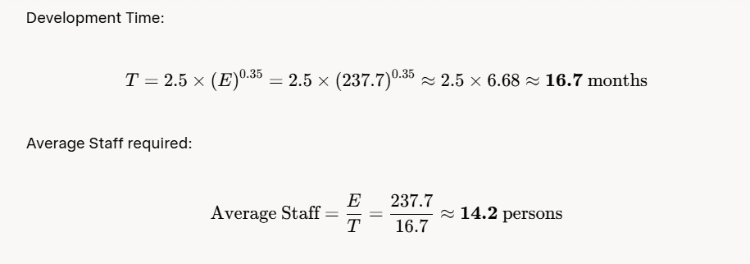

Intermediate COCOMO Example
Problem:
Same project (Semi-detached, 50 KLOC), but now we apply cost drivers.
Assume the following cost driver ratings (typical values):
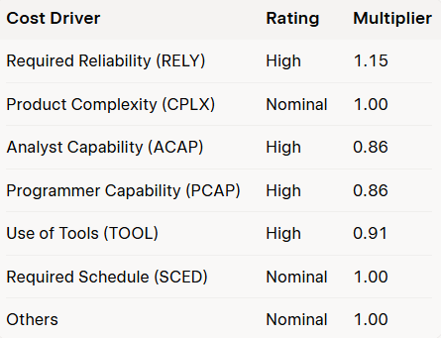

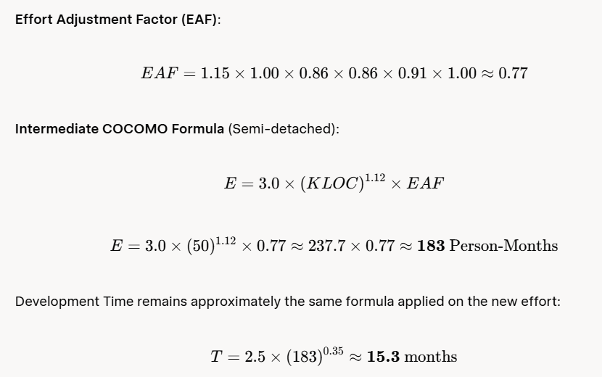

Putnam’s Software Equation Example


